About me…
My name is Mr Rob. I arrived in Hong Kong in 1993 and only intended to stay for two months. However, two months became 23 years as I fell in love with Hong Kong.

For the last six years, I have been living and teaching in a secondary school in Bali. Bali is a great place, especially for surfing which is my passion.
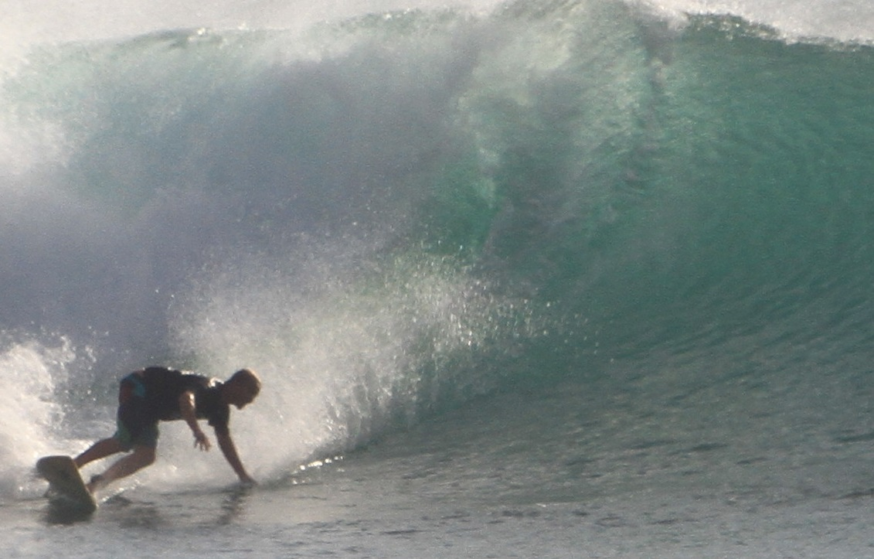
This is me in Bali ⇛

I have been an English teacher for 17 years
and look forward to this coming year at
Fukien Secondary School teaching Forms 1,
2 and 4.

Remember, when it comes to learning a language
‘Practice makes perfect’. Don’t be afraid to
use English in class for fear of making a
mistake. As Richard Branson says, “You don’t learn to walk by following rules. You learn by doing and falling over”.

