Don’t give yourself too many excuses Edward Chan

“I don’t need another reminder to tell me I can benefit a lot from reading but I’m just too occupied with all sorts of things like extracurricular activities and assignments.”

Does this quote sound all too familiar to you? Is that what you often say to yourself when urged to read by your English teacher?

Having suffered a lot of setbacks in their reading and speaking exams, my S5 students have come to understand that if they do not read at leisure, they will plough through the long passages in the DSE and lack ideas and expressions to effectively express themselves, ruining their chance to get the grade they desire in the DSE.

But couldn’t they realise this earlier and read more in form 4 or even earlier?

Some did realize the need in form 4. But they said they had no time to read. Some thought they would still have time to catch up on their reading in form 5. But we know one thing – one’s English skills cannot be built so easily in the space of two years. They too easily gave themselves all sorts of reasons for not doing what they should do.

Reading has always been one of my favourite pastimes. There are many reasons, and obviously one of which is a practical one as there is a constant need for me to brush up my English. But aside from that, I always derive pleasure from reading. I feel great whenever I learn a new thing – be it a new expression or a new idea. While it’s true that I have a tight schedule every day, I have come up with so many methods to make myself read more ranging from subscribing to various English fan pages on facebook (like BBC News, BBC Science News, The Guardian, SCMP Lifestyle, etc.) to setting some English webpages (like http://www.bbc.com/sport) as the start-up page of my browser. Therefore, every time I open my browser or facebook on my phone, lots of articles of my interest will pop up before my eyes.

I don’t need to be urged to read. Like I said, I simply enjoy reading. There are lots of sayings about the benefits of reading. Allow me to share some of my favourites with you below.
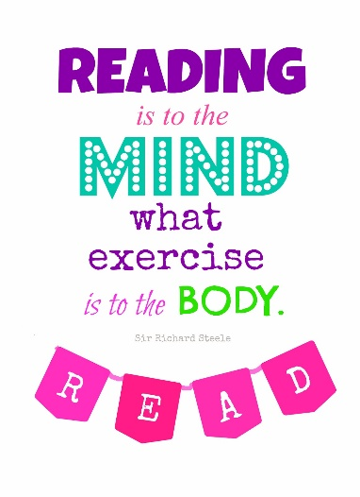
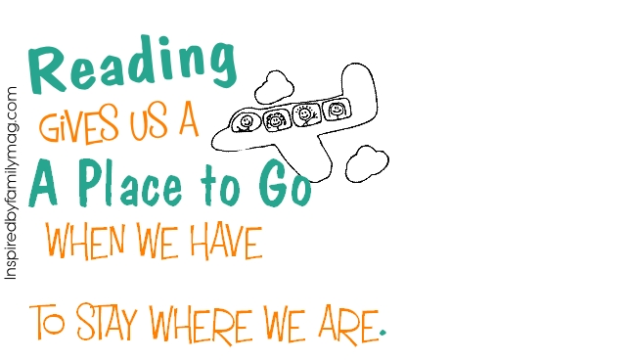
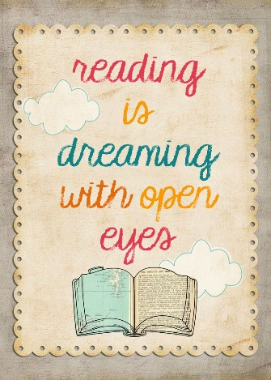
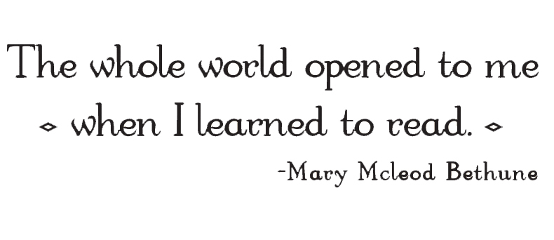
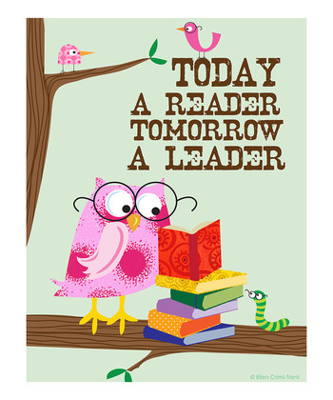
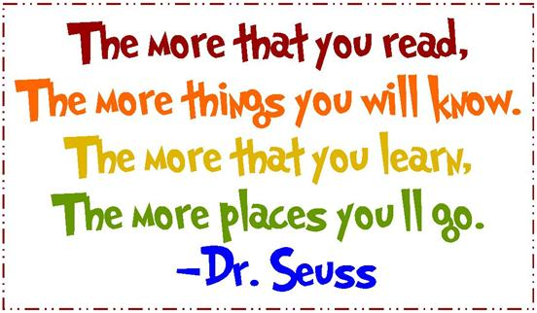

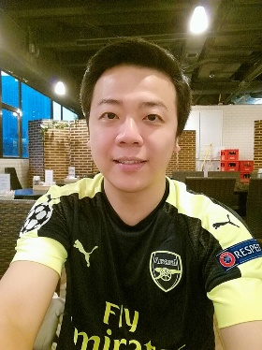
Today a reader, tomorrow a leader. It’s well-said, isn’t it?

So don’t give yourself too many excuses for not reading if you know so clearly that it is beneficial to you. I hope that all of you will find the joy of reading soon. If you still don’t find it now, maybe you haven’t come across the books you really like yet.

I’m so sure the joy will come naturally as you read more. Trust me.

